|  |  |  |  |
| --- | --- | --- | --- |
| **Project** | PCP_COC | **Data File** | SAMPLE001.wiff |
| **Instrument Name** | Triple Quad 5500+ | **Plate Position** | 1-2 |
| **Acquisition Date** | 4/30/2025 7:20:27 PM | **Result Table Date** | 5/1/2025 7:16:50 PM |
| **Acquisition Method** | PCP_BE_041422Final.dam | **Instrument Serial** | EX231582110 |

|  |  |  |  |  |
| --- | --- | --- | --- | --- |
| Quant Transition: | PCP 1 | 243.8 / 159.0 | PCP D5 1 | 248.8 / 164.1 |
| Qual Transition: | PCP 2 | 243.8 / 91.0 | PCP D5 1 | 248.8 / 164.1 |

**IS Peak Area Range (20% - 200% of mean):** 3.61e+05 – 3.61e+06

|  |
| --- |
| **IS Expected Ion Ratio:**PCP D5 1/PCP D5 1 100.0%(80.00% – 120.00%) |

|  |  |  |  |  |  |
| --- | --- | --- | --- | --- | --- |
| **Calibrator** | **IS Name** | **Integration Type** | **Retention Time (min)** | **IS Peak Area** | **Calculated Ion Ratio** |

|  |  |  |  |  |  |
| --- | --- | --- | --- | --- | --- |
| *CAL1* | PCP D5 1 | Baseline | 0.30 | 1.909e6 |  |
| PCP D5 1 | Baseline | 0.30 | 1.91e+06 | 100.0% |

|  |  |  |  |  |  |
| --- | --- | --- | --- | --- | --- |
| CAL2 | PCP D5 1 | Baseline | 0.30 | 1.870e6 |  |
| PCP D5 1 | Baseline | 0.30 | 1.87e+06 | 100.0% |

|  |  |  |  |  |  |
| --- | --- | --- | --- | --- | --- |
| CAL3 | PCP D5 1 | Baseline | 0.35 | 1.956e6 |  |
| PCP D5 1 | Baseline | 0.35 | 1.96e+06 | 100.0% |

|  |  |  |  |  |  |
| --- | --- | --- | --- | --- | --- |
| CAL4 | PCP D5 1 | Baseline | 0.32 | 1.893e6 |  |
| PCP D5 1 | Baseline | 0.32 | 1.89e+06 | 100.0% |

|  |  |  |  |  |  |
| --- | --- | --- | --- | --- | --- |
| CAL5 | PCP D5 1 | Baseline | 0.30 | 1.904e6 |  |
| PCP D5 1 | Baseline | 0.30 | 1.90e+06 | 100.0% |

|  |  |  |  |  |  |
| --- | --- | --- | --- | --- | --- |
| CAL6 | PCP D5 1 | Baseline | 0.29 | 1.772e6 |  |
| PCP D5 1 | Baseline | 0.29 | 1.77e+06 | 100.0% |

|  |  |  |  |  |  |
| --- | --- | --- | --- | --- | --- |
| CAL7 | PCP D5 1 | Baseline | 0.35 | 1.754e6 |  |
| PCP D5 1 | Baseline | 0.35 | 1.75e+06 | 100.0% |

|  |  |  |  |  |  |
| --- | --- | --- | --- | --- | --- |
| CAL8 | PCP D5 1 | Baseline | 0.32 | 1.486e6 |  |
| PCP D5 1 | Baseline | 0.32 | 1.49e+06 | 100.0% |

**Analyte Expected Ion Ratio:**PCP 2/PCP 1 59.4%(47.6% – 71.3%)

**Analyte Relative Retention Time:**1.01

|  |  |  |  |  |  |  |  |  |  |  |
| --- | --- | --- | --- | --- | --- | --- | --- | --- | --- | --- |
| **Calibrator** | **Injection Date and Time** | **Analyte Name** | **Integration Type** | **Ret Time (min)** | **Rel RT (min)** | **Analyte Peak Area** | **Area Ratio** | **Calc. Conc**  **(ng/mL)** | **% Accuracy** | **Calculated Ion Ratio** |

|  |  |  |  |  |  |  |  |  |  |  |
| --- | --- | --- | --- | --- | --- | --- | --- | --- | --- | --- |
| *CAL1* | 4/30/2025 7:27:50 PM | PCP 1 | Baseline | 0.30 | 1.01 | 8.848e4 | 0.046 | 8.49 | 84.95 |  |
| PCP 2 | Baseline | 0.30 | 1.01 | 6.841e4 | 0.036 |  |  | 77.3% |

|  |  |  |  |  |  |  |  |  |  |  |
| --- | --- | --- | --- | --- | --- | --- | --- | --- | --- | --- |
| CAL2 | 4/30/2025 7:28:59 PM | PCP 1 | Baseline | 0.30 | 1.02 | 2.379e5 | 0.127 | 25.39 | 101.56 |  |
| PCP 2 | Valley | 0.30 | 1.01 | 1.462e5 | 0.078 |  |  | 61.5% |

|  |  |  |  |  |  |  |  |  |  |  |
| --- | --- | --- | --- | --- | --- | --- | --- | --- | --- | --- |
| CAL3 | 4/30/2025 7:30:11 PM | PCP 1 | Baseline | 0.35 | 1.01 | 4.578e5 | 0.234 | 47.73 | 95.46 |  |
| PCP 2 | Baseline | 0.35 | 1.01 | 2.841e5 | 0.145 |  |  | 62.1% |

|  |  |  |  |  |  |  |  |  |  |  |
| --- | --- | --- | --- | --- | --- | --- | --- | --- | --- | --- |
| CAL4 | 4/30/2025 7:31:24 PM | PCP 1 | Baseline | 0.32 | 1.01 | 1.174e6 | 0.620 | 128.60 | 102.88 |  |
| PCP 2 | Baseline | 0.32 | 1.01 | 6.955e5 | 0.368 |  |  | 59.2% |

|  |  |  |  |  |  |  |  |  |  |  |
| --- | --- | --- | --- | --- | --- | --- | --- | --- | --- | --- |
| CAL5 | 4/30/2025 7:32:34 PM | PCP 1 | Baseline | 0.30 | 1.01 | 2.323e6 | 1.220 | 254.69 | 101.88 |  |
| PCP 2 | Baseline | 0.30 | 1.01 | 1.368e6 | 0.719 |  |  | 58.9% |

|  |  |  |  |  |  |  |  |  |  |  |
| --- | --- | --- | --- | --- | --- | --- | --- | --- | --- | --- |
| CAL6 | 4/30/2025 7:33:46 PM | PCP 1 | Baseline | 0.30 | 1.02 | 1.003e7 | 5.663 | 1205.61 | 96.45 |  |
| PCP 2 | Baseline | 0.30 | 1.01 | 5.895e6 | 3.327 |  |  | 58.8% |

|  |  |  |  |  |  |  |  |  |  |  |
| --- | --- | --- | --- | --- | --- | --- | --- | --- | --- | --- |
| CAL7 | 4/30/2025 7:34:57 PM | PCP 1 | Baseline | 0.36 | 1.01 | 2.051e7 | 11.700 | 2550.74 | 102.03 |  |
| PCP 2 | Baseline | 0.35 | 1.01 | 1.181e7 | 6.733 |  |  | 57.6% |

|  |  |  |  |  |  |  |  |  |  |  |
| --- | --- | --- | --- | --- | --- | --- | --- | --- | --- | --- |
| CAL8 | 4/30/2025 7:36:08 PM | PCP 1 | Baseline | 0.32 | 1.01 | 3.251e7 | 21.880 | 4987.72 | 99.75 |  |
| PCP 2 | Baseline | 0.32 | 1.01 | 1.888e7 | 12.710 |  |  | 58.1% |

**QC Results**

|  |  |  |  |  |  |  |
| --- | --- | --- | --- | --- | --- | --- |
| Vial | QC Name | Ratio Confirms ID | IS Area Within Range | Expected Concentration (ng/mL) | Calculated Concentration (ng/mL) | % Accuracy |
| 10 | NEG QC | ✓ | ✓ | 0.00 | N/A | N/A |
| 11 | CPC LOW QC | ✓ | ✓ | 32.69 | 30.08 | 92.02 |
| 12 | CPC MID QC | ✓ | ✓ | 2020.10 | 1872.06 | 92.67 |
| 13 | CPC HIGH QC | ✓ | ✓ | 4176.20 | 4019.42 | 96.25 |
| 12 | CPC MID QC | ✓ | ✓ | 2020.10 | 1933.97 | 95.74 |
| 53 | CPC MID3 | ✓ | ✓ | 2020.10 | 1876.26 | 92.88 |
| 74 | CPC PC | ✓ | ✓ | 2020.10 | 2008.48 | 99.42 |
| 87 | NEG QC | ✓ | ✓ | 0.00 | N/A | N/A |
| 88 | CPC HIGH QC | ✓ | ✓ | 4176.20 | 3921.98 | 93.91 |
| 89 | CPC MID QC | ✓ | ✓ | 2020.10 | 1913.93 | 94.74 |
| 90 | CPC MID QC | ✓ | ✓ | 2020.10 | 1899.83 | 94.05 |
| 91 | CPC LOW QC | ✓ | ✓ | 32.69 | 28.88 | 88.35 |
| 10 | NEG QC CO | ✓ | ✓ | 0.00 | N/A | N/A |
| 10 | NEG QC CO | ✓ | ✓ | 0.00 | N/A | N/A |
| 10 | NEG QC CO | ✓ | ✓ | 0.00 | N/A | N/A |
| 10 | NEG QC CO | ✓ | ✓ | 0.00 | N/A | N/A |
| 88 | CPC HIGH QC CO | ✓ | ✓ | 4176.20 | 3990.93 | 95.56 |
| 89 | CPC MID QC CO | ✓ | ✓ | 2020.10 | 1965.12 | 97.28 |
| 90 | CPC MID QC CO | ✓ | ✓ | 2020.10 | 1944.28 | 96.25 |
| 91 | CPC LOW QC CO | ✓ | ✓ | 32.69 | 30.66 | 93.79 |

#### **Regression Equation:**

y = -8.09513e-8 x^2 + 0.00479 x + 0.00567 (r = 0.99940) (weighting: 1 / x^2)

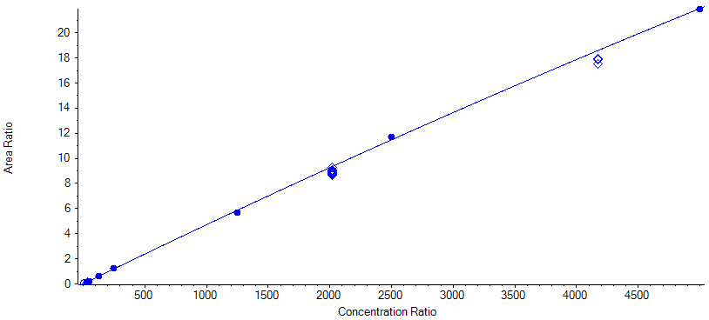

**CAL1** 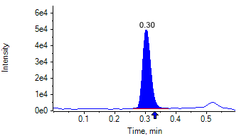

**PCP 2** 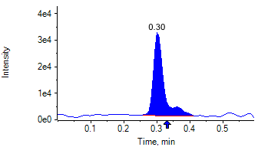

**PCP D5 1** 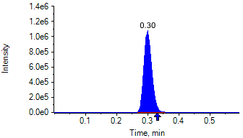

**PCP D5 1** 

**CAL2** 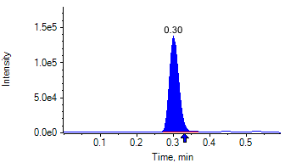

**PCP 2** 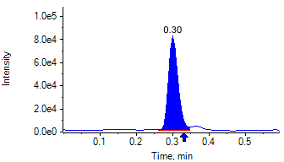

**PCP D5 1** 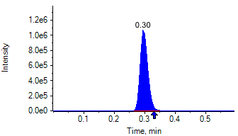

**PCP D5 1** 

**CAL3** 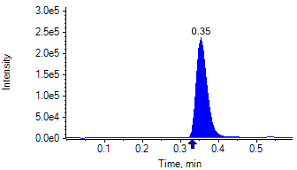

**PCP 2** 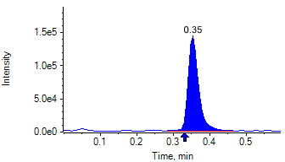

**PCP D5 1** 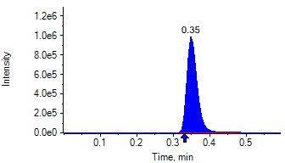

**PCP D5 1** 

**CAL4** 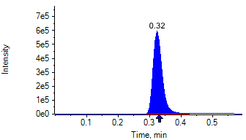

**PCP 2** 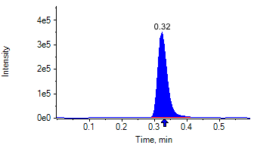

**PCP D5 1** 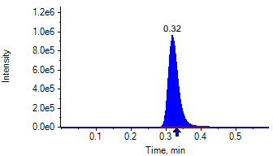

**PCP D5 1** 

**CAL5** 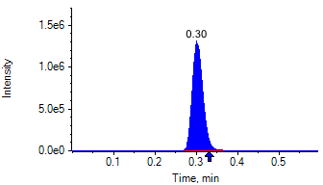

**PCP 2** 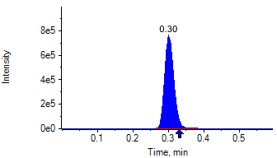

**PCP D5 1** 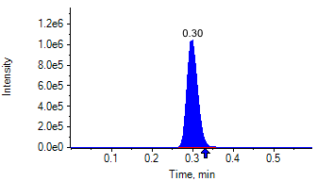

**PCP D5 1** 

**CAL6** 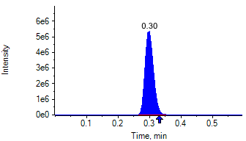

**PCP 2** 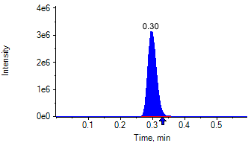

**PCP D5 1** 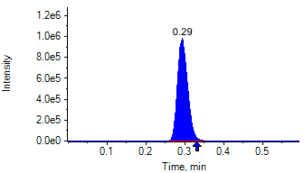

**PCP D5 1** 

**CAL7** 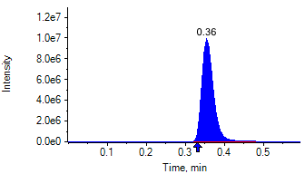

**PCP 2** 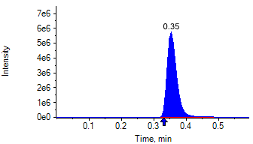

**PCP D5 1** 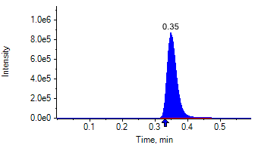

**PCP D5 1** 

**CAL8** 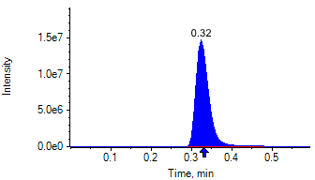

**PCP 2** 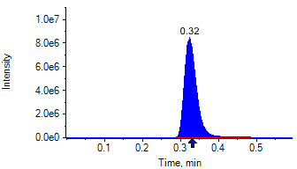

**PCP D5 1** 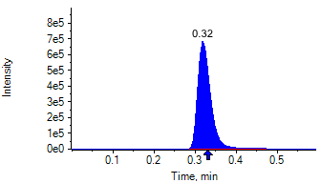

**PCP D5 1** 

|  |  |  |  |
| --- | --- | --- | --- |
| **Project** | PCP_COC | **Data File** | SAMPLE001.wiff |
| **Instrument Name** | Triple Quad 5500+ | **Plate Position** | 1-2 |
| **Acquisition Date** | 4/30/2025 7:20:27 PM | **Result Table Date** | 5/1/2025 7:16:50 PM |
| **Acquisition Method** | PCP_BE_041422Final.dam | **Instrument Serial** | EX231582110 |

|  |  |  |  |  |
| --- | --- | --- | --- | --- |
| Quant Transition: | Benzoylecgonine 1 | 289.8 / 168.1 | Benzoylecgonine D3 1 | 292.8 / 171.2 |
| Qual Transition: | Benzoylecgonine 2 | 289.8 / 104.9 | Benzoylecgonine D3 1 | 292.8 / 171.2 |

**IS Peak Area Range (20% - 200% of mean):** 3.77e+05 – 3.77e+06

|  |
| --- |
| **IS Expected Ion Ratio:**Benzoylecgonine D3 1/Benzoylecgonine D3 1 100.0%(80.00% – 120.00%) |

|  |  |  |  |  |  |
| --- | --- | --- | --- | --- | --- |
| **Calibrator** | **IS Name** | **Integration Type** | **Retention Time (min)** | **IS Peak Area** | **Calculated Ion Ratio** |

|  |  |  |  |  |  |
| --- | --- | --- | --- | --- | --- |
| CAL1 | Benzoylecgonine D3 1 | Baseline | 0.17 | 2.004e6 |  |
| Benzoylecgonine D3 1 | Baseline | 0.17 | 2.00e+06 | 100.0% |

|  |  |  |  |  |  |
| --- | --- | --- | --- | --- | --- |
| CAL2 | Benzoylecgonine D3 1 | Baseline | 0.16 | 2.117e6 |  |
| Benzoylecgonine D3 1 | Baseline | 0.16 | 2.12e+06 | 100.0% |

|  |  |  |  |  |  |
| --- | --- | --- | --- | --- | --- |
| CAL3 | Benzoylecgonine D3 1 | Baseline | 0.20 | 2.010e6 |  |
| Benzoylecgonine D3 1 | Baseline | 0.20 | 2.01e+06 | 100.0% |

|  |  |  |  |  |  |
| --- | --- | --- | --- | --- | --- |
| CAL4 | Benzoylecgonine D3 1 | Baseline | 0.18 | 2.096e6 |  |
| Benzoylecgonine D3 1 | Baseline | 0.18 | 2.10e+06 | 100.0% |

|  |  |  |  |  |  |
| --- | --- | --- | --- | --- | --- |
| CAL5 | Benzoylecgonine D3 1 | Baseline | 0.17 | 1.968e6 |  |
| Benzoylecgonine D3 1 | Baseline | 0.17 | 1.97e+06 | 100.0% |

|  |  |  |  |  |  |
| --- | --- | --- | --- | --- | --- |
| CAL6 | Benzoylecgonine D3 1 | Baseline | 0.16 | 1.825e6 |  |
| Benzoylecgonine D3 1 | Baseline | 0.16 | 1.83e+06 | 100.0% |

|  |  |  |  |  |  |
| --- | --- | --- | --- | --- | --- |
| CAL7 | Benzoylecgonine D3 1 | Baseline | 0.20 | 1.620e6 |  |
| Benzoylecgonine D3 1 | Baseline | 0.20 | 1.62e+06 | 100.0% |

|  |  |  |  |  |  |
| --- | --- | --- | --- | --- | --- |
| CAL8 | Benzoylecgonine D3 1 | Baseline | 0.18 | 1.431e6 |  |
| Benzoylecgonine D3 1 | Baseline | 0.18 | 1.43e+06 | 100.0% |

**Analyte Expected Ion Ratio:**Benzoylecgonine 2/Benzoylecgonine 1 71.7%(57.3% – 86.0%)

**Analyte Relative Retention Time:**1.02

|  |  |  |  |  |  |  |  |  |  |  |
| --- | --- | --- | --- | --- | --- | --- | --- | --- | --- | --- |
| **Calibrator** | **Injection Date and Time** | **Analyte Name** | **Integration Type** | **Ret Time (min)** | **Rel RT (min)** | **Analyte Peak Area** | **Area Ratio** | **Calc. Conc**  **(ng/mL)** | **% Accuracy** | **Calculated Ion Ratio** |

|  |  |  |  |  |  |  |  |  |  |  |
| --- | --- | --- | --- | --- | --- | --- | --- | --- | --- | --- |
| CAL1 | 4/30/2025 7:27:50 PM | Benzoylecgonine 1 | Valley | 0.17 | 1.02 | 1.637e4 | 0.008 | 39.78 | 99.45 |  |
| Benzoylecgonine 2 | Baseline | 0.17 | 1.02 | 1.125e4 | 0.006 |  |  | 68.7% |

|  |  |  |  |  |  |  |  |  |  |  |
| --- | --- | --- | --- | --- | --- | --- | --- | --- | --- | --- |
| CAL2 | 4/30/2025 7:28:59 PM | Benzoylecgonine 1 | Valley | 0.17 | 1.02 | 4.324e4 | 0.020 | 102.70 | 102.70 |  |
| Benzoylecgonine 2 | Baseline | 0.17 | 1.01 | 3.153e4 | 0.015 |  |  | 72.9% |

|  |  |  |  |  |  |  |  |  |  |  |
| --- | --- | --- | --- | --- | --- | --- | --- | --- | --- | --- |
| CAL3 | 4/30/2025 7:30:11 PM | Benzoylecgonine 1 | Baseline | 0.21 | 1.02 | 7.669e4 | 0.038 | 193.76 | 96.88 |  |
| Benzoylecgonine 2 | Baseline | 0.21 | 1.01 | 5.591e4 | 0.028 |  |  | 72.9% |

|  |  |  |  |  |  |  |  |  |  |  |
| --- | --- | --- | --- | --- | --- | --- | --- | --- | --- | --- |
| CAL4 | 4/30/2025 7:31:24 PM | Benzoylecgonine 1 | Baseline | 0.19 | 1.02 | 2.052e5 | 0.098 | 501.06 | 100.21 |  |
| Benzoylecgonine 2 | Baseline | 0.19 | 1.01 | 1.517e5 | 0.072 |  |  | 73.9% |

|  |  |  |  |  |  |  |  |  |  |  |
| --- | --- | --- | --- | --- | --- | --- | --- | --- | --- | --- |
| CAL5 | 4/30/2025 7:32:34 PM | Benzoylecgonine 1 | Baseline | 0.17 | 1.02 | 3.917e5 | 0.199 | 1022.78 | 102.28 |  |
| Benzoylecgonine 2 | Baseline | 0.17 | 1.02 | 2.835e5 | 0.144 |  |  | 72.4% |

|  |  |  |  |  |  |  |  |  |  |  |
| --- | --- | --- | --- | --- | --- | --- | --- | --- | --- | --- |
| CAL6 | 4/30/2025 7:33:46 PM | Benzoylecgonine 1 | Baseline | 0.16 | 1.02 | 1.738e6 | 0.952 | 4972.94 | 99.46 |  |
| Benzoylecgonine 2 | Baseline | 0.16 | 1.02 | 1.228e6 | 0.673 |  |  | 70.7% |

|  |  |  |  |  |  |  |  |  |  |  |
| --- | --- | --- | --- | --- | --- | --- | --- | --- | --- | --- |
| CAL7 | 4/30/2025 7:34:57 PM | Benzoylecgonine 1 | Baseline | 0.21 | 1.02 | 2.979e6 | 1.839 | 9782.46 | 97.82 |  |
| Benzoylecgonine 2 | Baseline | 0.21 | 1.01 | 2.133e6 | 1.316 |  |  | 71.6% |

|  |  |  |  |  |  |  |  |  |  |  |
| --- | --- | --- | --- | --- | --- | --- | --- | --- | --- | --- |
| CAL8 | 4/30/2025 7:36:08 PM | Benzoylecgonine 1 | Baseline | 0.19 | 1.02 | 5.227e6 | 3.653 | 20244.00 | 101.22 |  |
| Benzoylecgonine 2 | Baseline | 0.19 | 1.02 | 3.679e6 | 2.571 |  |  | 70.4% |

**QC Results**

|  |  |  |  |  |  |  |
| --- | --- | --- | --- | --- | --- | --- |
| Vial | QC Name | Ratio Confirms ID | IS Area Within Range | Expected Concentration (ng/mL) | Calculated Concentration (ng/mL) | % Accuracy |
| 10 | NEG QC | ✓ | ✓ | 0.00 | N/A | N/A |
| 11 | CPC LOW QC | ✓ | ✓ | 128.10 | 115.16 | 89.90 |
| 12 | CPC MID QC | ✓ | ✓ | 7916.90 | 7691.49 | 97.15 |
| 13 | CPC HIGH QC | ✓ | ✓ | 16383.10 | 15819.86 | 96.56 |
| 12 | CPC MID QC | ✓ | ✓ | 7916.90 | 7531.94 | 95.14 |
| 53 | CPC MID3 | ✓ | ✓ | 7916.90 | 7684.73 | 97.07 |
| 74 | CPC PC | ✓ | ✓ | 7916.90 | 7644.97 | 96.57 |
| 87 | NEG QC | ✓ | ✓ | 0.00 | N/A | N/A |
| 88 | CPC HIGH QC | ✓ | ✓ | 16383.10 | 15680.89 | 95.71 |
| 89 | CPC MID QC | ✓ | ✓ | 7916.90 | 7721.34 | 97.53 |
| 90 | CPC MID QC | ✓ | ✓ | 7916.90 | 7450.13 | 94.10 |
| 91 | CPC LOW QC | ✓ | ✓ | 128.10 | 150.80 | 117.72 |
| 10 | NEG QC CO | ✓ | ✓ | 0.00 | N/A | N/A |
| 10 | NEG QC CO | ✓ | ✓ | 0.00 | N/A | N/A |
| 10 | NEG QC CO | ✓ | ✓ | 0.00 | N/A | N/A |
| 10 | NEG QC CO | ✓ | ✓ | 0.00 | N/A | N/A |
| 88 | CPC HIGH QC CO | ✓ | ✓ | 16383.10 | 16375.35 | 99.95 |
| 89 | CPC MID QC CO | ✓ | ✓ | 7916.90 | 8064.44 | 101.86 |
| 90 | CPC MID QC CO | ✓ | ✓ | 7916.90 | 8179.19 | 103.31 |
| 91 | CPC LOW QC CO | ✓ | ✓ | 128.10 | 141.50 | 110.46 |

#### **Regression Equation:**

y = -7.17560e-10 x^2 + 1.94945e-4 x + 4.13535e-4 (r = 0.99973) (weighting: 1 / x^2)

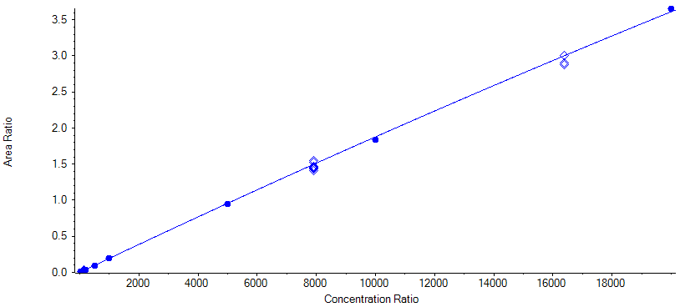

**CAL1** 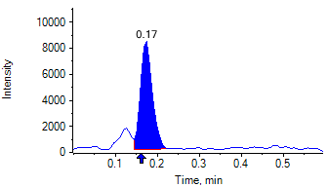

**Benzoylecgonine 2** 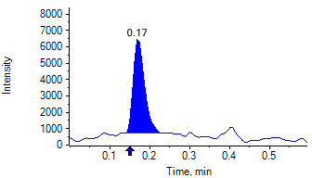

**Benzoylecgonine D3 1** 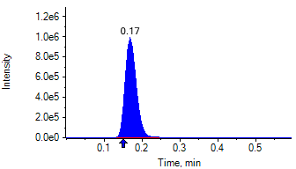

**Benzoylecgonine D3 1** 

**CAL2** 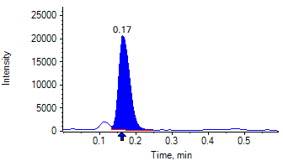

**Benzoylecgonine 2** 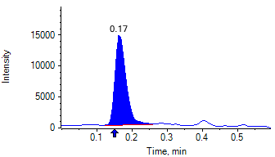

**Benzoylecgonine D3 1** 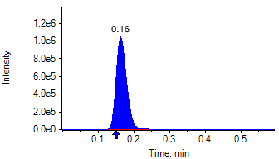

**Benzoylecgonine D3 1** 

**CAL3** 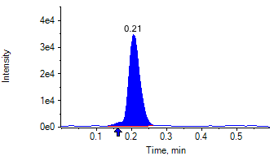

**Benzoylecgonine 2** 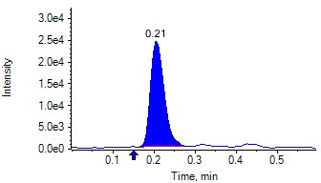

**Benzoylecgonine D3 1** 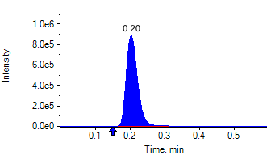

**Benzoylecgonine D3 1** 

**CAL4** 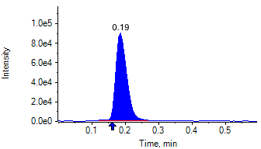

**Benzoylecgonine 2** 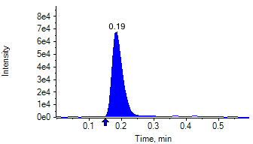

**Benzoylecgonine D3 1** 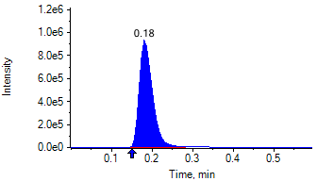

**Benzoylecgonine D3 1** 

**CAL5** 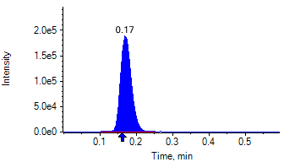

**Benzoylecgonine 2** 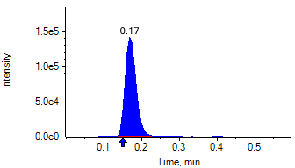

**Benzoylecgonine D3 1** 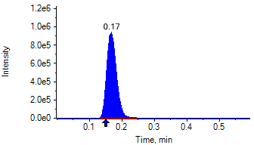

**Benzoylecgonine D3 1** 

**CAL6** 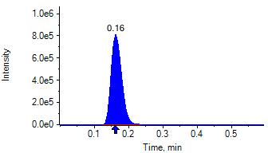

**Benzoylecgonine 2** 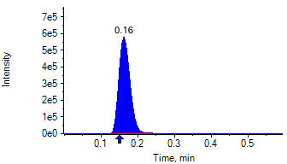

**Benzoylecgonine D3 1** 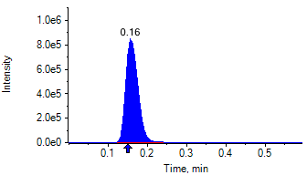

**Benzoylecgonine D3 1** 

**CAL7** 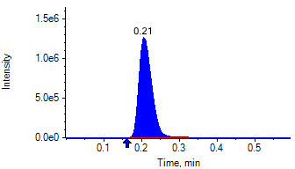

**Benzoylecgonine 2** 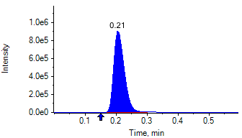

**Benzoylecgonine D3 1** 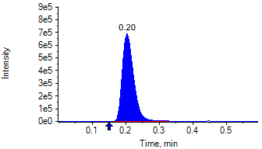

**Benzoylecgonine D3 1** 

**CAL8** 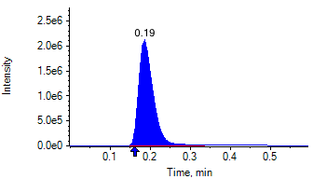

**Benzoylecgonine 2** 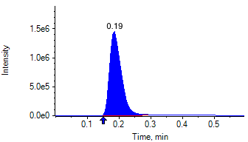

**Benzoylecgonine D3 1** 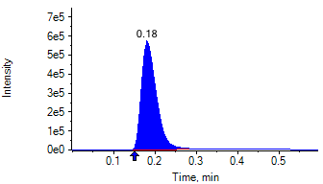

**Benzoylecgonine D3 1** 